In 2021-2023, the DQQ was implemented in the Gallup World Poll to collect nationally representative diet quality data in 85 countries. These data were collected among a sample of ~1,000–3,500 people per country, aged 15 years and older, and were analyzed by gender and urban/rural status. We describe these results, with a view toward scaled global coverage in the future. Data collection is underway in an additional 8 countries, which will be available in 2025.

**Results**

**Fig. 1 | Minimum dietary diversity for women aged 15–49 years.** Data are from the Diet Quality Questionnaire in the 2021–2023 Gallup World Poll. The season in which the data were collected varied across countries, so differences between countries may be due in part to differences in season.

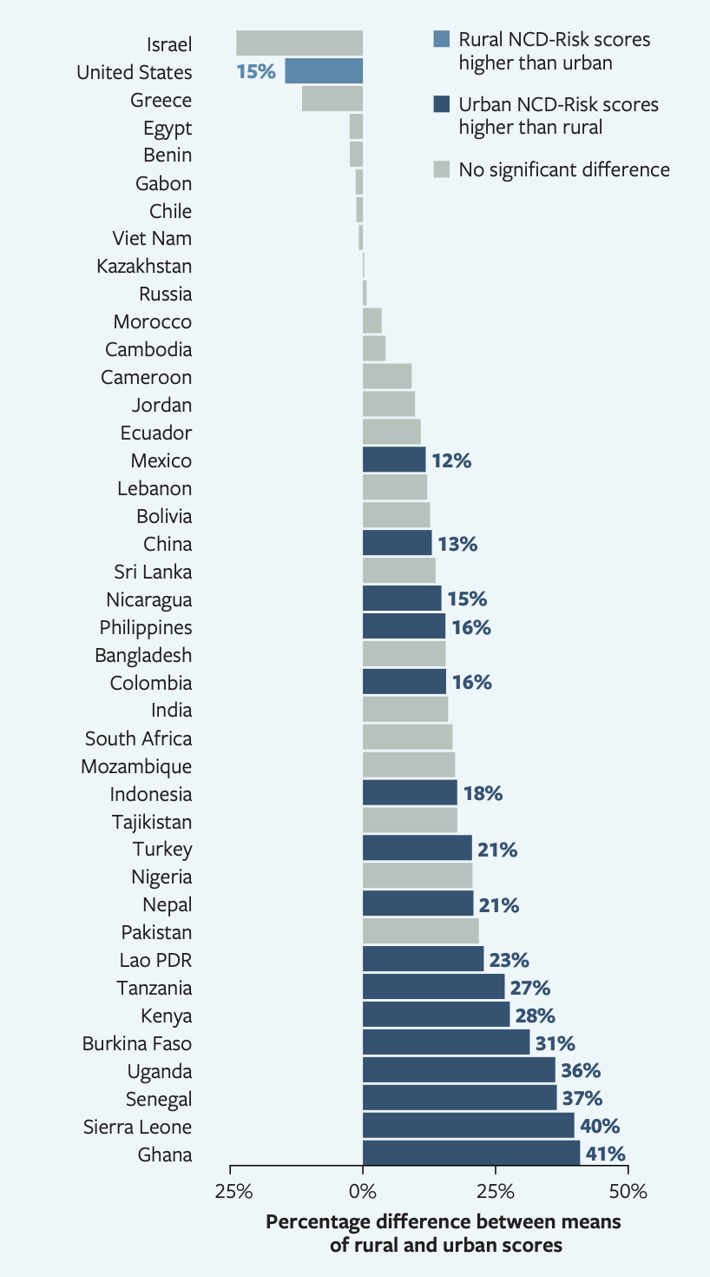

**Fig. 2 | Urban-Rural differences in NCD-Risk among adults aged ≥ 15 years.** Data are from the Diet Quality Questionnaire in the 2021–2023 Gallup World Poll. Light blue and dark blue bars indicate significant differences at p < 0.05 using a two-sample t-test. Assignment as an urban or rural locality was based on harmonized categories from the European Commission (XX countries) when available and on self-report otherwise (XX countries).

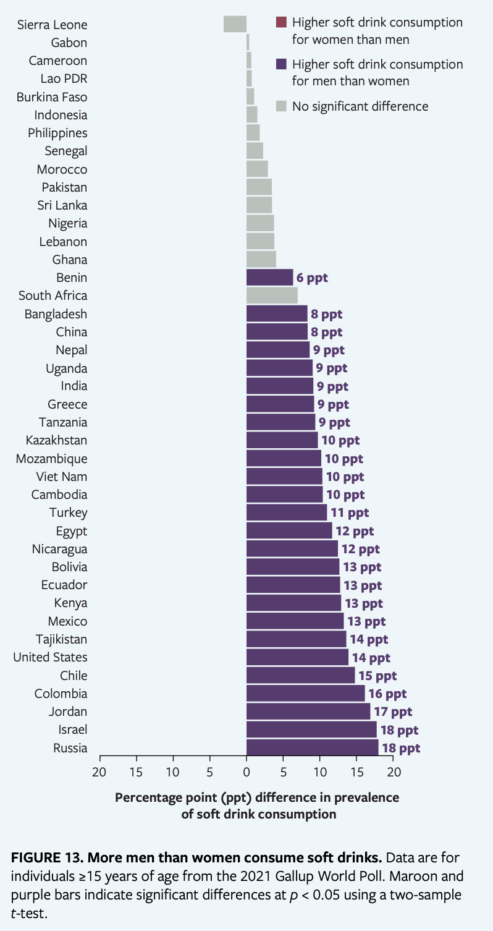

**Fig. 3 | Gender differences in sugar-sweetened beverage consumption among adults aged ≥ 15 years.** Data are from the Diet Quality Questionnaire in the 2021–2023 Gallup World Poll. Maroon and purple bars indicate significant differences at p < 0.05 using a two-sample t-test.

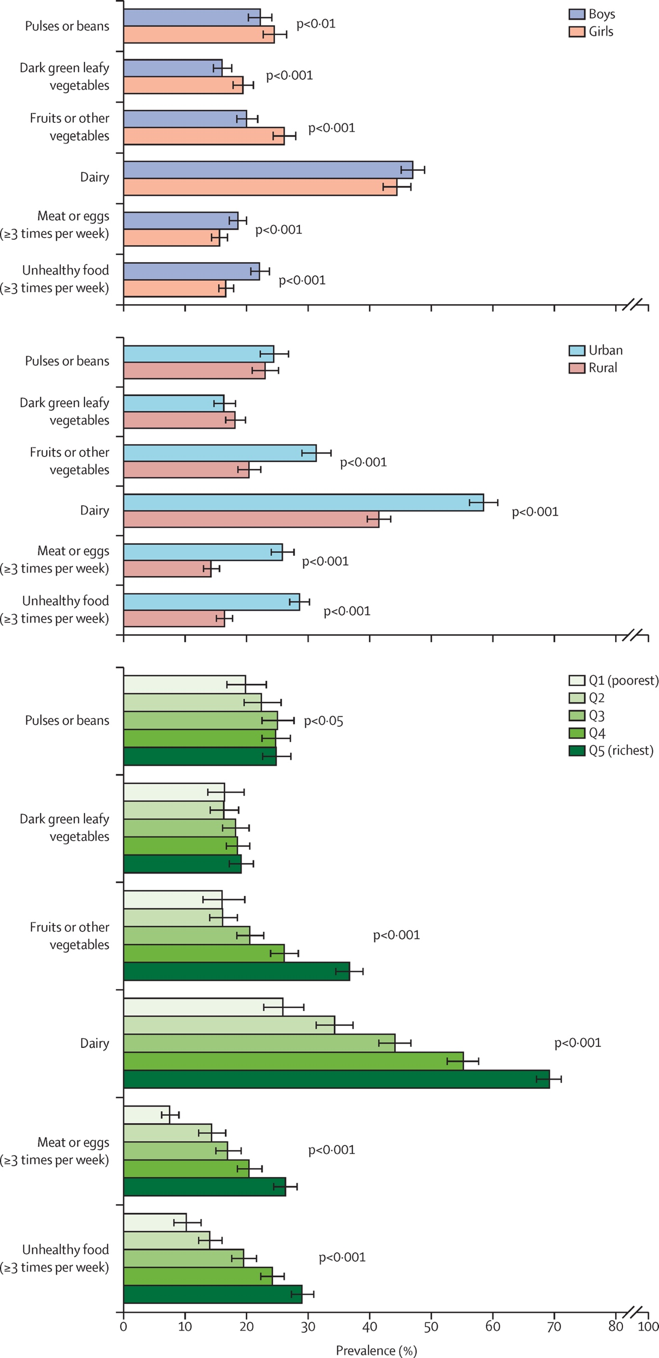

**Fig. 4 | Variation in diet quality among adults ≥ 15 years by income quintile.** Data are from the Diet Quality Questionnaire in the 2021–2023 Gallup World Poll. Error bars show 95% confidence intervals. Data are pooled across 85 countries with a total sample size of XX. The p values are for differences between income quintiles. Q=quintile.

**Fig. 5 | Linear regression analysis of the relationship between the proportion of people who cannot afford a healthy diet and the proportion of adults ≥ 15 years who did not consume all five recommended food groups.** Data on affordability are from XX–XX in the XX. Data on consumption are from the Diet Quality Questionnaire in the 2021–2023 Gallup World Poll. The sizes of the circles indicate the country population sizes. The p value indicates the statistical significance of the bivariate linear relationship.

**Fig. 6 | Linear regression analysis of the relationship between the retail value of ultraprocessed food sales per person and ultraprocessed food consumption among adults ≥ 15 years.** Data on food sales are from 2021 by Euromonitor. Data on consumption are from the Diet Quality Questionnaire in the 2021–2023 Gallup World Poll. The sizes of the circles indicate the country population sizes. The p value indicates the statistical significance of the bivariate linear relationship.

Additional figures that may be in the main text or supplemental material…

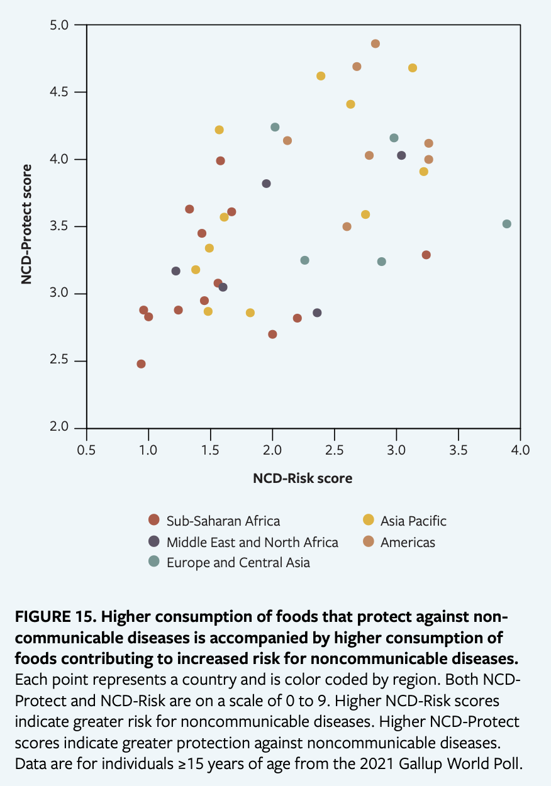

**Fig. 7 | Linear regression analysis of the relationship between NCD-Risk and NCD-Protect adults ≥ 15 years.** Data are from the Diet Quality Questionnaire in the 2021–2023 Gallup World Poll. The p value indicates the statistical significance of the bivariate linear relationship.

**Fig. 8 | Variation in diet quality among adults ≥ 15 years by World Bank income group.** Data are from the Diet Quality Questionnaire in the 2021–2023 Gallup World Poll. Error bars show 95% confidence intervals. Data are pooled across 85 countries with a total sample size of XX. The p values are for differences between income groups.

**Fig. 9 | Diet quality among adults ≥ 15 years for those reporting that they did and did not have enough money for food.** Data are from the Diet Quality Questionnaire in the 2021–2023 Gallup World Poll. Error bars show 95% confidence intervals. Data are pooled across 85 countries with a total sample size of XX. The p values are for differences between income groups.

**Fig. 10 | Differences in diet quality among adults ≥ 15 years by education.** Data are from the Diet Quality Questionnaire in the 2021–2023 Gallup World Poll. Error bars show 95% confidence intervals. Data are pooled across 85 countries with a total sample size of XX. The p values are for differences between income groups.

**Table 1. Associations between diet quality, nutritional status, food security, hunger**

Ty’s suggestion

|  |  |  |  |
| --- | --- | --- | --- |
| Diet indicator | Stunting | Moderate or severe food insecurity | Hunger |
| DDS or MDD-W |  |  |  |
| All-5 |  |  |  |
| NCD-Protect |  |  |  |
| NCD-Risk |  |  |  |
|  |  |  |  |
|  |  |  |  |
|  |  |  |  |

**Supplementary Material**

This could have a lot of graphs!

And an annex table like we had in our Measuring What the World Eats report.

**Fig S1 – Map of existing surveys**

**Fig S2. National income and Healthy / Unhealthy foods**

Bar chart of country income classification and average NCD-Risk and NCD-Protect (pooled) – try using dichotomous versions (prevalence) from Doris’ email on the WHO indicator